support.ewon.biz

Application User Guide
AUG 068 / Rev. 1.0

Build your IIOT project with eWON Flexy

1. Introduction 3
2. My little IIOT project with M2Web and viewON 3
3. Collect Flexy data through the Talk2M Datamailbox 4
Introduction 4
DataMailBox compatible software 4
MyLittleHistorian (https://developer.ewon.biz/) 4
Ignition (https://inductiveautomation.com/) 5
PLUTO Live Report (http://www.exacom.com) 8
IOThink Solutions (www.iothink-solutions.com) 9
Fetch 9
eSync Datamailbox driver 10
Fetch 10
Amplia 10
Segno 10
Promotic 10
4. Send your Flexy data to servers directly 11
Introduction 11
Some Flexy compatible server solution examples 11
eSync 11
Cumulocity 11
Bluemix, IOT Watson 12
IOTHub by Microsoft Azure 12
EMONCMS (http://emoncms.org) 12
CARRIOTS (https://www.carriots.com/) 13
Opensensors.io (https://opensensors.io) 15
TINAMOUS (https://tinamous.com/) 16
Thingspeak (https://thingspeak.com/) 17
UBIDOTS (https://ubidots.com/) 18
Revision 20
Revision History 20

Introduction
As you may already know, Flexy is able to poll data (aka Tags or Registers) from any kind of field devices such as PLC or meters. It supports all the major PLC brands (Siemens, AB, ABB, Mitsubishi, VIPA, Hitachi, Omron and Modbus) thanks to its exhaustive list of IO drivers. Moreover, if a field protocol is not supported, it can even be developed through BASIC scripting or JAVA. Once you get the field data into the Tags of your Flexy, the data can be logged on a time or deadband based into a memory of maximum of 1.000.000 timestamped records.
To build an IIOT project from these Flexy data, you'll have somehow to export the data to an IIOT application. An IIOT application is vague name to define a cloud or local server based application that process and add value to the field data in order to serve the user's targets. For example, a machine builder can anticipate the maintenance of his machines by monitoring and recording some parameters of the machine.
This document will give you some hints on how you can use the Flexy to build your IIOT projects.

My little IIOT project with M2Web and viewON
Since one of the first aspect of an IIOT project is to view the field data remotely, the combination of M2Web and viewON may be seen as a first step IIOT project.
- M2Web is a Talk2M service that allows you to see the Flexy webpages from anywhere in the world. The only thing you need is an Internet connection and a web browser.
- ViewON is a WYSIWYG tool that allows you to create local dashboards for your Flexy
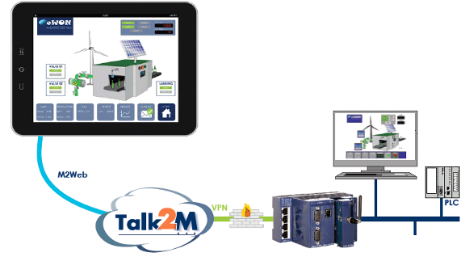

Collect Flexy data through the Talk2M Datamailbox

Introduction
The eWON cloud platform “Talk2M” features a Data aggregation service named “DatamailBox”. This DataMailbox acts as a big historical data buffer in the cloud.
The idea is that all your Flexys will push their historical data to the DataMailbox through the VPN connection previously established with Talk2M. Third party software such as historian, reporting software, ERP or SCADA will then be able to gather the Flexy's historical data through a simple HTTPS RestFul API named “DMWeb API”.

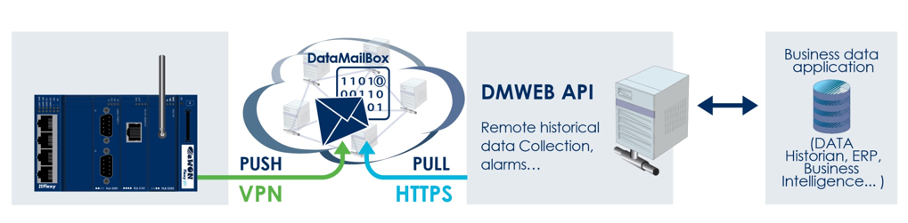
You can find more information about it on https://developer.ewon.biz/content/dmweb-api

The Talk2M DataMailbox combined with a partner solution provides customers a plug&play solution that requires no programming but just configuration.

DataMailBox compatible software
Let's see what are the different software on the market that have already done the effort to develop a fully integrated DataMailBox driver.

MyLittleHistorian (https://developer.ewon.biz/)
Provided with the DMWebAPI SDK, this C# program is more an example about how to use the DMWeb API. It retrieves the eWONs historical data from the DataMailBox and generate CSV files. (https://developer.ewon.biz/sites/default/files/Talk2MSDK.zip)
Another software example based on the MyLittleHistorian is “MyCSVHistorian” which is more flexible regarding the format of the CSV file generated (https://techforum.ewon.biz/thread-183.html)

Ignition (https://inductiveautomation.com/)
Ignition is an industrial application platform developed by the company “Inductive Automation”. This software provides powerful tools to build SCADA, MES and IIOT solutions.

Inductive Automation has now developed a DataMailBox module called “eWON Connector”. This one allows you to connect your Talk2M DataMailBox in a few minutes. You just need to enter your account credentials as well as a developer ID and that's it.

Once it is configured, you can create a project and associate the Datamailbox driver to any kind of databases.
When the project is running, the historical data are retrieved and all the Tags are created automatically. You then just need to pick up the Tags you want for each object you put in your views.

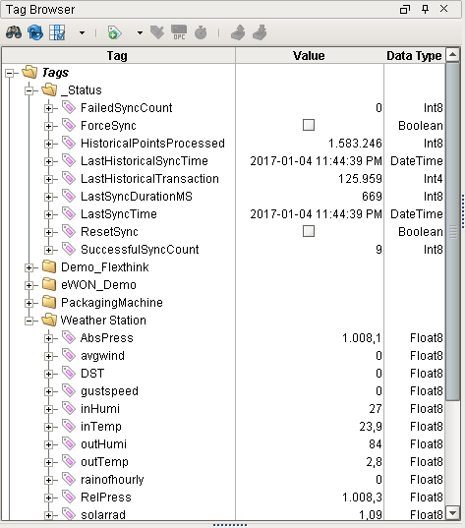
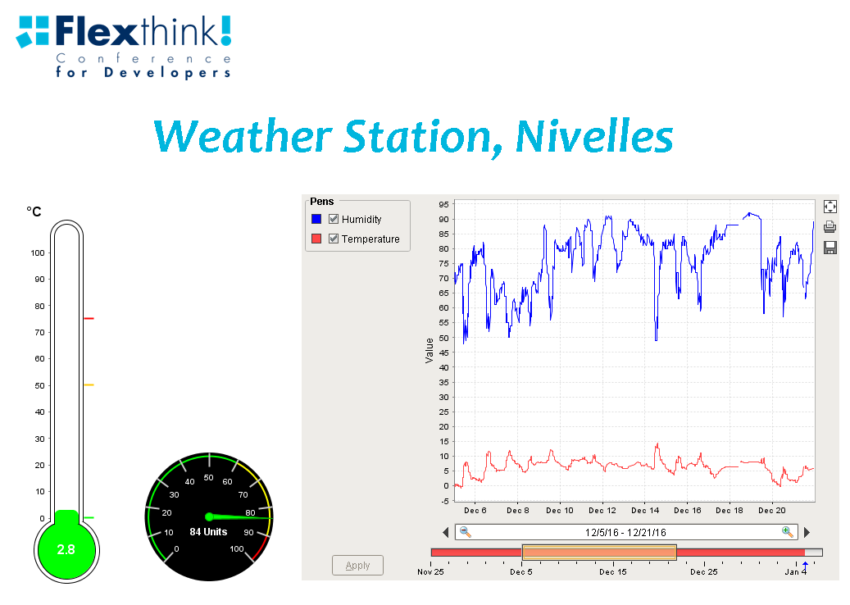
If you also need to send commands to your Flexys, you can use the M2WebAPI but it will require to create a short python script in yours views.

PLUTO Live Report (http://www.exacom.com)
PLUTO LIVE REPORT is a fully integrated and configurable DASHBOARDING and REPORTING software enabling to:
- Aggregate and leverage data from multiple databases (Historians, Scada, Dcs, Files repository...)
- Log clean and accurate real time data, alarms and statistics (OPC Servers, PLC, RTU, Meters, ...)
- Feed data to other applications such as enterprise software (PLUTO, BI, MES, ERP systems …)
- Visualize data analysis in LIVE, PLAY BACK and DASHBOARDING mode
- Generate and email automatically reports in multiple formats (PDF, XLS, XPS)
- Publish reports over the internet

Pluto fully supports the data collection from the Talk2M DataMailbox through its “eWON” driver.

In a few clicks, you'll be able to collect your Flexy Historical Data and export them to any kind of databases. Next, up to you to create reports and dashboards using all the features provided by the software.

IOThink Solutions (www.iothink-solutions.com)
IOThink Solutions is a French company providing complete IOT solutions from the sensor and edge router (using eWON) up to the IOT cloud plaform.
This IOT cloud platform is called “Kheiron” and supports the Datamailbox as well as the M2Web APIs (for the commands).
Iothink Solutions offers to integrate your data and create dashboards in their platform themselves.

eSync Datamailbox driver (http://www.ewon.biz)
For those who like eSync, a Datamailbox driver for eSync has been developed so that you can easily aggregate the Flexy historical and alarm data to the eSync MySQL Database. In parallel, the Push method can still be used.
More Info on https://ewon.biz/sites/default/files/kb-0243-0-en_esync_datamailbox_connector.pdf

Fetch (https://www.mac-solutions.net/en/fetch-download)

Fetch software is a product from M.A.C. Solutions (UK) Ltd. Its designed to connect to eWON devices directly or via the Talk2M Datamailbox and collect logged data, on a required schedule. Data can be then pushed to CSV files (various formats can be used) or to any kind of databases (through ODBC connections).
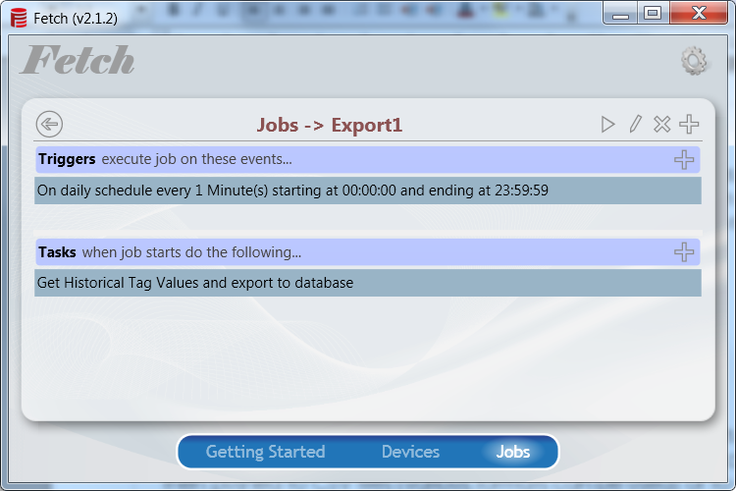
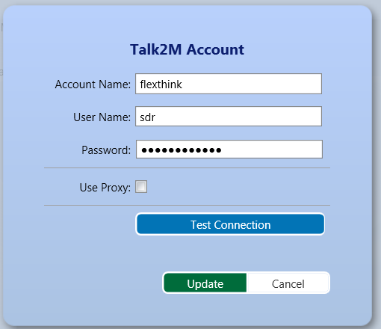

Amplia
https://ewon.biz/sites/default/files/upload/docs/Partners/ewonpartner_amplia_EN.PDF

Segno

eagle technology (http://www.eaglecmms.com/en/)

Promotic
Segno
http://scante.net/

Send your Flexy data to servers directly

Introduction
This chapter exposes different ways for sending data from your Flexys to your own platform, without going through Talk2M.
Indeed, the Flexy can send its real-time, historical and alarms data through FTP, HTTP(s) or MQTT in the form of binary or text data (csv, json,...).
This sending can be triggered on a time based, by an alarm, via a BASIC Script or a JAVA application.
The content of these data files can be easily defined by using an export block descriptor (For example : $dtHL$dtT will export the historical logging in a CSV format). However, with EBD, the file format used will be fixed and if a custom data format is needed, it must be coded into your BASIC or Java program.
In some IIOT projects, pushing the historical data of Flexy is not required. Only the real-time data (Current Tag values) is pushed to the IIOT application and the IIOT application then records these data as timestamped data.
This kind of projects almost often requires a high level of integration as well as programming skills.
More info on https://developer.ewon.biz

Some Flexy compatible server solution examples

eSync
eSync is an eWON software that allows you to gather historical and alarm data from your Flexys and store it into a MySQL database (other MySQL instances cannot be used). The MySQL Database must be seen as Data Buffer (FIFO) from where any of your third party applications that feature a MySQL connector can grab your Flexy's data.
To make it work, eSync must be installed on a Windows server. As we use here the “push technology”, it is the Flexy that connects to eSync to push its data in HTTP(S).
More info on TBD

Cumulocity
Cumulocity is an IOT cloud platform that allows to collect data from multiple sources and display them in charts or widgets objects.
Flexy is able to send its data to Cumulocity via HTTPS or MQTT. This requires you develop a BASIC script or a JAVA application in Flexy.
You'll find an example of BASIC script that sends real-time Tag values to Cumulocity via HTTPS on https://techforum.ewon.biz/ and via MQTT on https://techforum.ewon.biz/

Bluemix, IOT Watson

Bluemix IOT Watson is an IBM IOT cloud platform allowing to gather field data, mainly through MQTT. It also offers a various range of applications that can help to enhance your IOT application.
To get your Flexy pushes its data to IOT watson, it requires you develop a BASIC script or a JAVA application.
You'll find an example of BASIC program that pushes real-time Tag values to Bluemix via MQTT on https://techforum.ewon.biz/

IOTHub by Microsoft Azure
Blabla

EMONCMS (http://emoncms.org)
Emoncms is an open-source energy management software that provides features that are useful in a wider range of IoT applications. It allows to create easily dashboards to visualize your data through graphical objects and trends.
The software can be hosted on the cloud as well as on your own server.
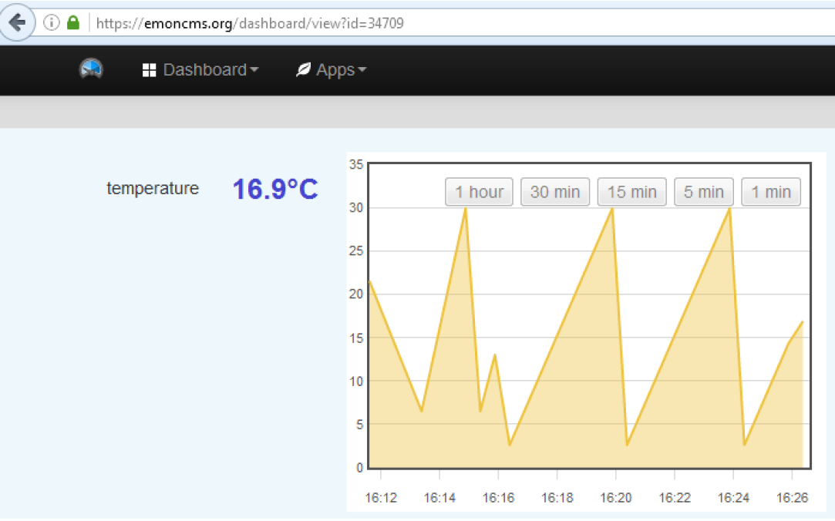
The upload of the data to Emoncms is done through a simple POST HTTP. For this, a API Key is required and can be found in your account settings. To post data from your eWON, you have the possibility to do it via a BASIC Script or a JAVA program.
- Note -
An example of script can found on the techforum https://techforum.ewon.biz/showthread.php?tid=137

CARRIOTS (https://www.carriots.com/)
Carriots is a cloud Platform as a Service (PaaS) designed for Internet of Things (IoT) and Machine to Machine (M2M) projects. It provides a REST API SDK to allows field devices to push the data to the system.
You can then organize and group your devices through a fully customizable hierarchy.
Once everything is set, you can define dashboard or build your own application based on your data.
The platform is not free of charge.

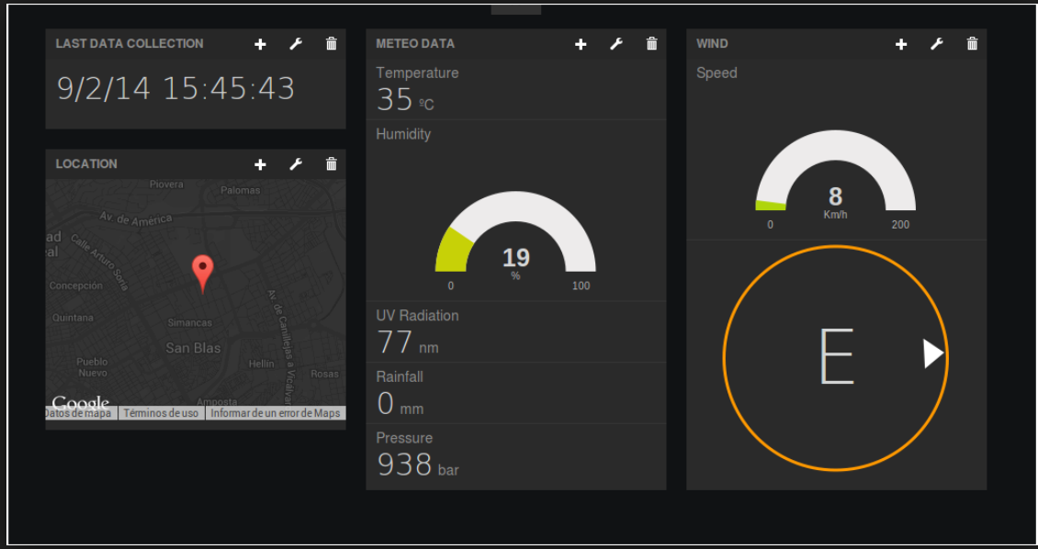
On the eWON side, the tag values can be pushed via a BASIC script or a JAVA program.
- Note -
An example of script can found on the techforum https://techforum.ewon.biz/showthread.php?tid=146

Opensensors.io (https://opensensors.io)
Opensensors.oi is an simple free-of-charge IOT cloud platform that mainly allows to concentrate the data on a server and then share them with a predefined screen generated from a given template. You can decide to share publicly or not. Opensensors.io does not support dashboards or other data analysis tools (trends,...).
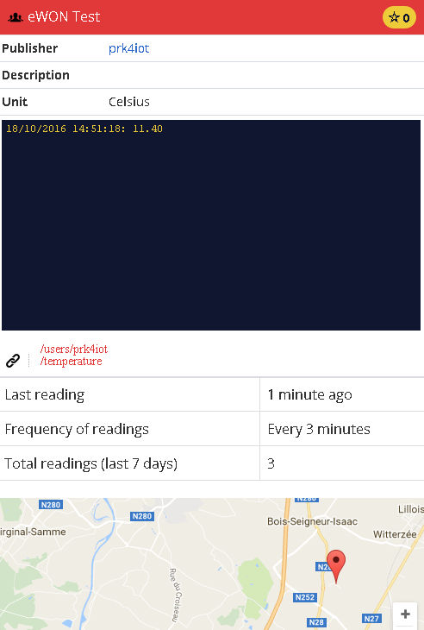
On the eWON side, the tag values can be pushed via a BASIC script or a JAVA program.
- Note -
An example of script can found on the techforum https://techforum.ewon.biz/showthread.php?tid=147

TINAMOUS (https://tinamous.com/)
Tinamous is an IOT cloud platform that allows to gather data from your device thanks to an HTTP REST API. You can then create multiple dashboards and trends from these data.

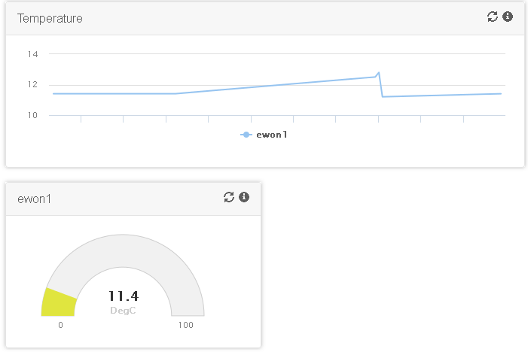
The platform offers a free account with some limitations (25 devices, 5 dashboards,...).

To connect the eWON to your Tinamous account, you just have to create a device. The "Tags" (called "Fields") are created on the fly when the device pushes new data.
- Note -
An example of script can found on the techforum https://techforum.ewon.biz/showthread.php?tid=148

Thingspeak (https://thingspeak.com/)
Thingspeak is an IOT cloud platform that allows to create dashboards composed of live graphs. Thingspeak can be seen as an IOT Tweeter. Indeed, these dashboards can be set a public channel so that you can share your data to any other Thingspeak member.
The configuration interface is very intuitive and easy. You just have to declare a channel and some field values associated and the data can then be simply pushed using a POST request.
ThingSpeak pricing is based on a count of messages to be processed and stored in a one-year period. However, ThingSpeak is available as a free service for non-commercial small projects

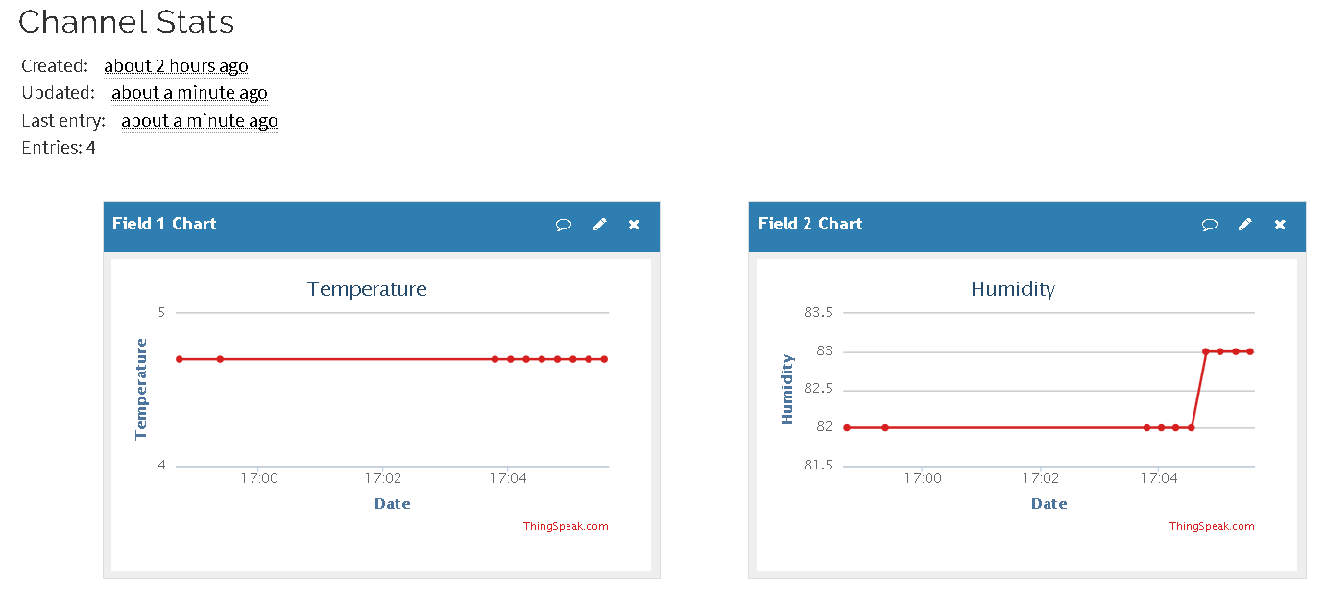
- Note -
An example of script can found on the techforum :
https://techforum.ewon.biz/thread-197.html

UBIDOTS (https://ubidots.com/)
Ubidots is a web IOT platform allowing to create dashboards with many different widgets and trends.
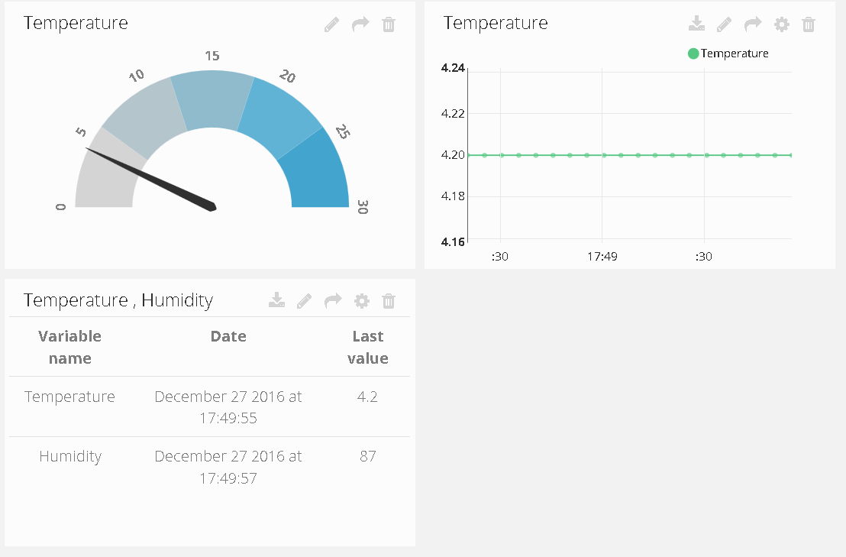
To push the data, a HTTP RestFul protocol is used in combination with Json data.
The configuration interface is quite friendly. You just need to define a new Data Source and its associated variables. Each variable has an ID and this ID will have to be used when pushing the data.
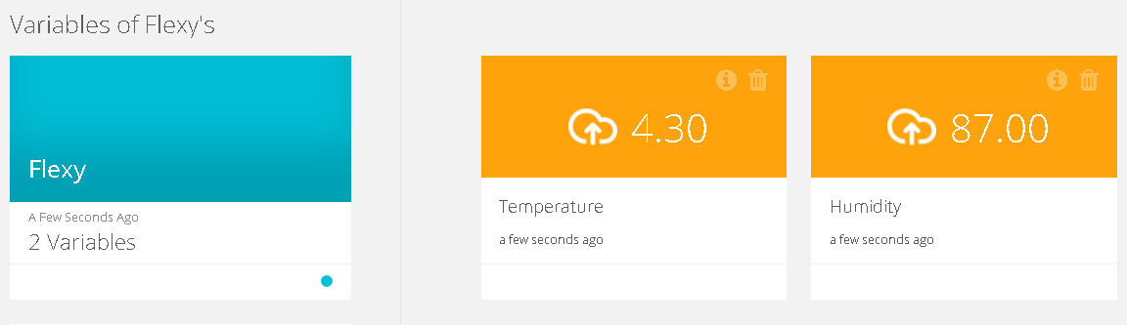
- Note -
An example of script can found on the techforum :
https://techforum.ewon.biz/thread-198.html

Revision

Revision History
Revision Level | Date | Description
1.0 | 01/01/0001 | Description
1.1 | 01/01/0001 | Description
Document build number: 150
Note concerning the warranty and the rights of ownership:
The information contained in this document is subject to modification without notice. Check http://ewon.biz/support for the latest documents releases.
The vendor and the authors of this manual are not liable for the errors it may contain, nor for their eventual consequences.
No liability or warranty, explicit or implicit, is made concerning the quality, the accuracy and the correctness of the information contained in this document. In no case can the manufacturer's responsibility be implied for direct, indirect, accidental or other damage occurring from any defect of the product or mistakes coming from this document.
The product names are mentioned in this manual for information purposes only. The trade marks and the product names or marks contained in this document are the property of their respective owners.
This document contains materials protected by the International Copyright Laws. All reproduction rights are reserved. No part of this handbook can be reproduced, transmitted or copied in any way without written consent from the manufacturer and/or the authors of this handbook.
eWON sa, Member of ACT'L Group

