Customise Alarm Actions

Request
How can I customise the Alarm eMail (or SMS)?

Solution
The only way to customize the Alarm eMail (SMS) is to handle all Alarm Actions by script.
You need to do 3 littles tasks:
- Catch the alarm event with the ONALARM event handler instruction.
- Format the eMail the way you want by building a String.
- Send the eMail with the SendMail instruction.

The Init_Section of the eWON will contain:
ONALARM "TagTest","GOTO ProcessTagTestAlarm"

You need to create a new section holding:
ProcessTagTestAlarm:
A% = ALSTAT("TagTest")
PRINT Time$;" TagTest alarm ";A%
IF (A%=2) THEN
Rem Send eMail only when the alarm occurs
N$ = CHR$(10)+CHR$(13) : Rem CRLF
A$ = "This is my customised alarm eMail for tag TagTest" + N$
A$ = A$ + "The current value of TagTest is " + STR$(TagTest@) + N$
A$ = A$ + "The current time is " + TIME$

SENDMAIL "user@company.com","","TagTest alarm Subject",A$
ENDIF

END

REM: The Alarm Event is triggered every time that the Alarm State change.
Then, you need to test on which Alarm State your Tag is.

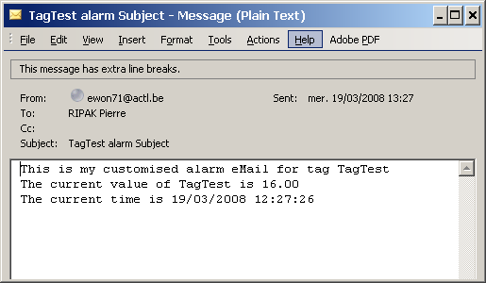
This will produce an eMail like the following:

