How to establish a Leased Line connection in FW4.3

Link two sites using eWON Leased Line
To be able to link both sites together following rules must be fulfilled:
- eWON client and eWON server IP addresses must not be compatible. Otherwise the routing will not be possible.
Valid IP addresses are for example:
eWON client 192.168.0.10, Mask 255.255.255.0
eWON server 192.168.10.10, Mask 255.255.255.0
- The Ethernet devices behind each eWON must have the eWON IP address as default gateway
- Both eWONs can be connected together using a 2 wire cable (crossed or not)

Configure the eWON client
The link is established by the CLIENT. This Client eWON can be configured with following parameters:
Modem Init String | LLCLT or LLCLT;AT&FE1...
Call direction allowed | Outgoing only
Primary Server Phone number | 0
Primary Server User Name | adm
Primary Server Password | adm
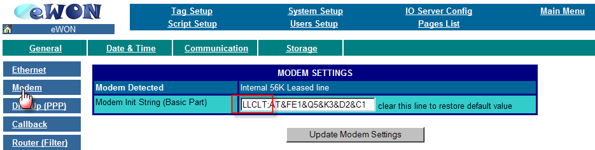

Modem Configuration

Dial Up (PPP) Configuration
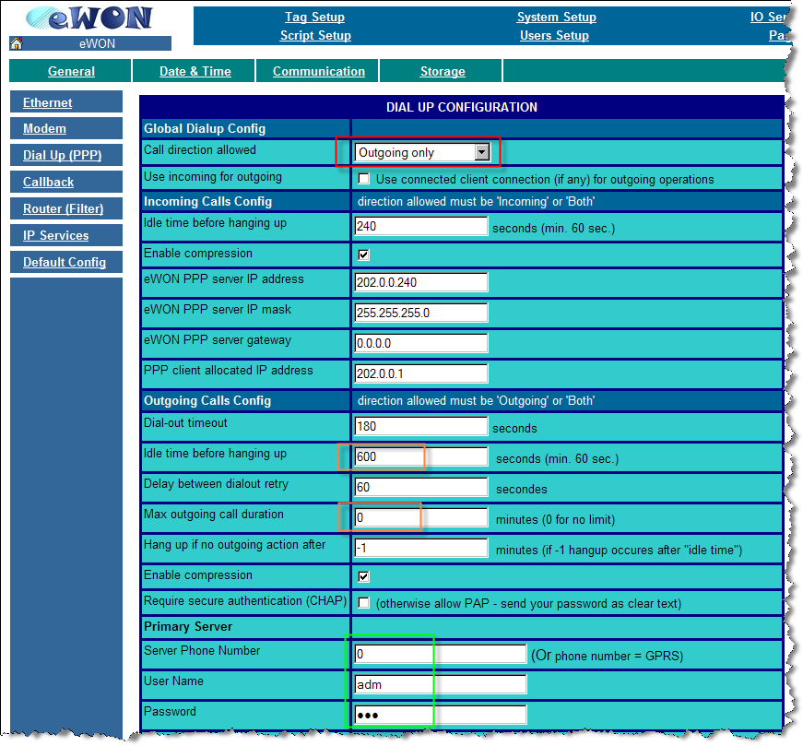
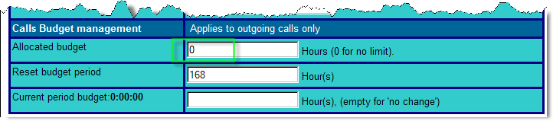
You will probably also need to adapt the Outgoing calls connection duration parameters and the Call Budget management parameters.
Outgoing Calls Config:
Idle Time before hanging up | 600, means that eWON will drop the line after 600 seconds if there is no traffic between both eWONs
Max Call out duration | 0 for no connection duration limit

Calls Budget management:
Allocated budget | 0 to deactivate the call budget management on the outgoing connection.

Router configuration
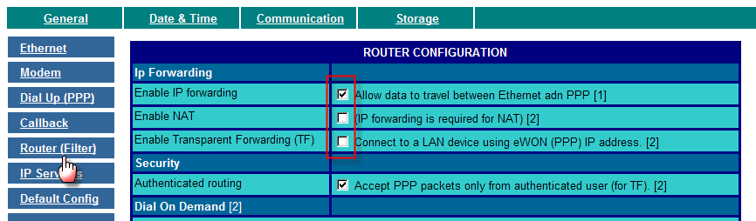
To allow eWON to act as router between the telephone and the Ethernet connection, the «IP forwarding» feature must be enabled sing following menu: Configuration/ system Setup/ Communication/ Router

Check the «Enable IP forwarding» and uncheck the «Enable NAT» and «Enable Transparent Forwarding» feature.

FTP server configuration
To trigger the modem connection, the eWON client will send out a file to the eWON server using a put FTP. Therefore we need to specify the FTP server access under Configuration/ system Setup/ General/ General
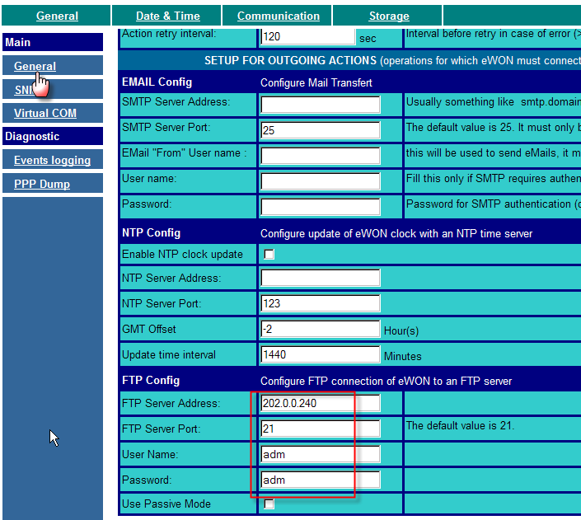

Basic program
The following program will allow to trigger the leased line connection every time the connection is broken down.
Put following program in the Init Section:
-----
TSET 1, 60
ONTIMER 1, "GOTO CHECKConnection"

CHECKConnection:
A$ = Getsys PRG, "PPPIP"
IF A$ = "0.0.0.0" THEN
PUTFTP "/usr/connection.txt", "Connection realized at " + Time$
ENDIF
END
------
Don't forget to configure the eWON to start the script after a reboot. (Configuration / Script Setup/ Script Control)Basic program
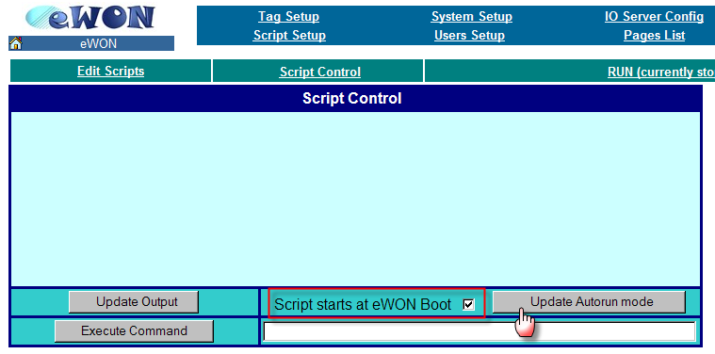

Reboot your eWON
Reboot your eWON to take all the settings into account.

Configure the eWON server

The eWON Server can be configured with following parameters:
Modem Init String | LLSRV or LLSRV;AT&FE1...
Call direction allowed | Incoming Only

Modem Configuration
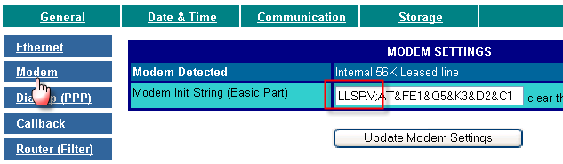

Dial Up (PPP) Configuration
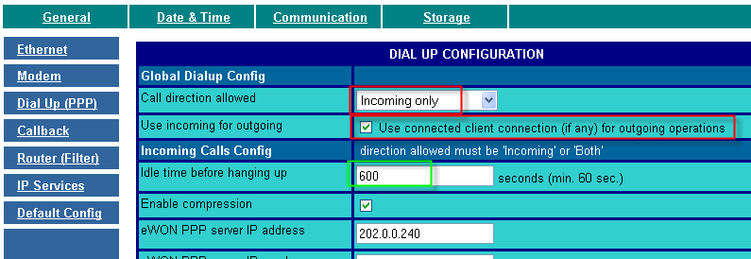
If the devices behind the eWON server need to communicate with devices behind the eWON client, then the «Use incoming for outgoing» check box need to be enabled.
You will probably also need to adapt the Outgoing calls connection duration parameters.
Idle Time before hanging up | 600, means that eWON will drop the line after 600 seconds if there is no traffic between both eWONs

Router configuration
To allow eWON to act as router between the telephone and the Ethernet connection, the «IP forwarding» feature must be enabled sing following menu: Configuration/ system Setup/ Communication/ Router

Check the «Enable IP forwarding» and uncheck the «Enable NAT» and «Enable Transparent Forwarding» feature.

Reboot your eWON
Reboot your eWON to take all the settings into account.

