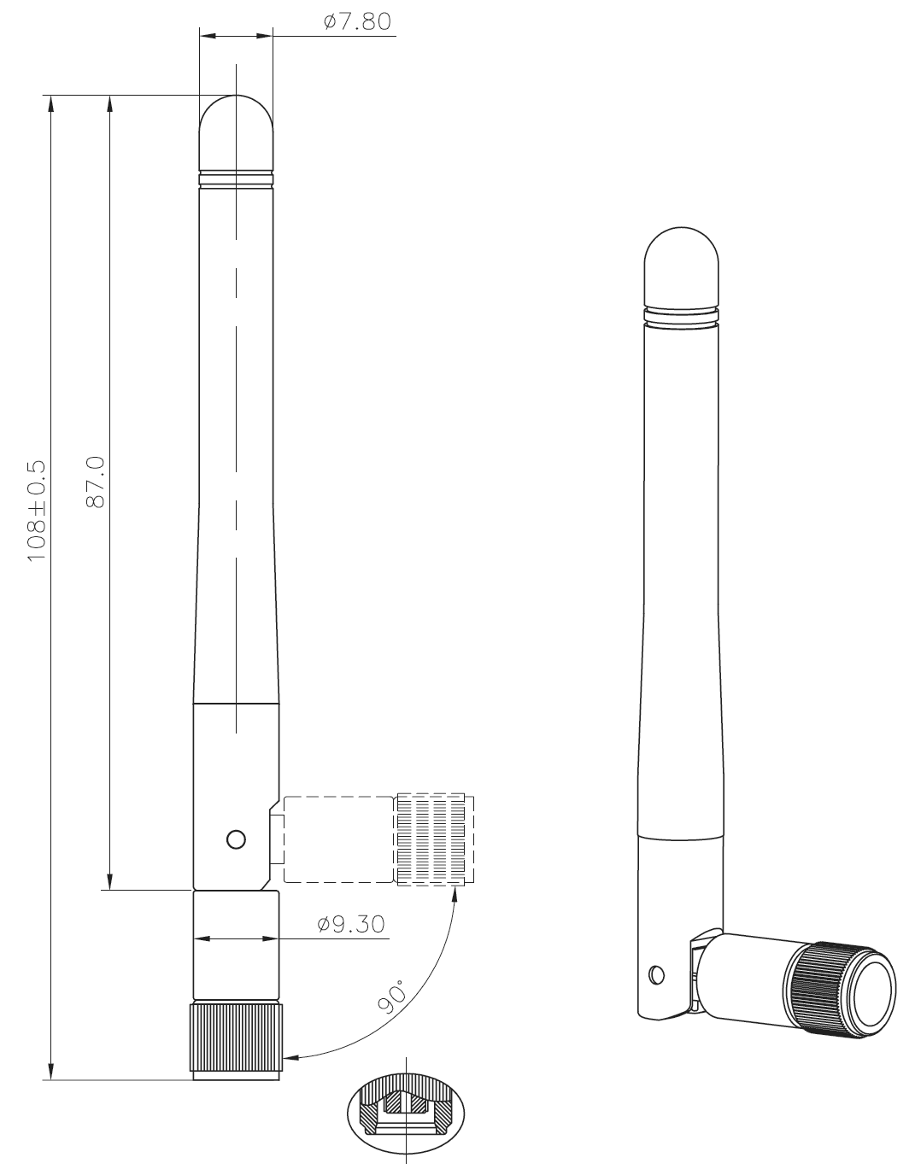
2G/3G GSM antenna + cable kit

Antenna description

Electrical
Frequency Range | 800 MHz  900 MHz  1800 MHz  1900 MHz  2100 MHz
Impedance | 50Ω
V.S.W.R. | ≤2.0
Radiation | Omni
Electrical Wave | ½ λ, Dipole
Polarization | Vertical
Mechanical
Antenna Cover | Plastic
Antenna Base | Plastic
Color | Black
Operating Temperature | -20°C to +65°C
Storage Temperature | -30°C to +75°C
Cable | RG-178
Connector | SMA Male Reverse

Cable description
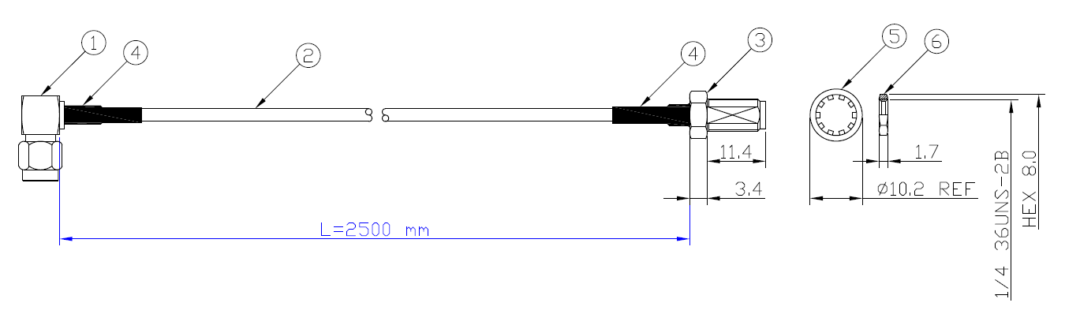
1 | SMA right angle Plug (gold)
2 | RG174-MIT coaxial cable (Black)
3 | SMA bulkhead jack (Gold)
4 | Heatshrink (Black)
5 | Washer
6 | Nut

