eSync - Database backup and cleanup

Introduction
eSync must be seen as an historical data gateway between your eWONs and your own Data management system (a third party software).
Therefore, the MySql database of eSync should be considered as a temporary database. You should, for example, erase older data out of the eSync Database to avoid that it grows too rapidly and overloads the whole system.
To help you to manage the eSync Mysql database, we provide two utilities :
- A Database Cleaner utility
- A Database Backup utility

Database Cleaner Utility
eSync 1.5 provides a simple procedure to clean-up old history data from the DB.
This procedure is not enabled by default.
To activate the Database cleaner, simply launch the installdbcleanup.bat file, which can be found under following directory: ...\eSync\MySql\installdbcleanup.bat
The BAT file prompts you to enter the historical data lifetime. Enter here the number of days you want to keep the historical data.
Warning | The installdbcleanup.bat file must be executed using the option “Run As Administrator” (Right-Click → Run as Administrator)

That's all. Once a day the eSync database will now be cleaned up.

How does the Data Cleaner work ?
The Cleaner utility is based on three files :
- ...\eSync\WebSite\cleandb.php
This PHP Script file contains all the code that clears the old historical data from the database. It takes as argument the maximum historical data lifetime in days (By default : 365 days).

- ...\eSync\MySql\dbcleanup.bat
BAT file that launches the PHP script above. It also takes as argument the maximum historical data lifetime in days.

- ...\eSync\MySql\installdbcleanup.bat
BAT file that registers a new task in the Task Scheduler of Windows (See snapshot below). This task will launch the file “dbcleanup.bat” every night at 2 AM. Before registering the task, the BAT file prompts you to enter the historical data lifetime.
The task parameters can be customized in the Windows task Scheduler. The name of the Task is “eSyncCleanup”.

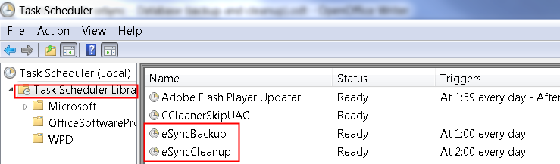

Database Backup Utility
eSync 1.5 contains a simple daily backup procedure (Backup of the MySQL DB). This procedure is not enabled by default.
To activate the Database backup, simply launch the installdbbackup.bat file, which can be found under following directory: ...\eSync\MySql\installdbbackup.bat
Warning | The installdbbackup.bat file must be executed using the option “Run As Administrator” (Right-Click → Run as Administrator)

That's all.
Once a day a dump of the MySQL DB will now be created and zipped inside the ...\eSync\MySQL\backup directory. Zipped files older than 30 days are automatically deleted.

How does the Data Backup work ?

The backup utility is based on two files :
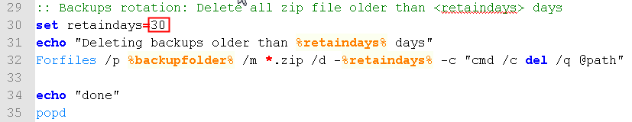
- ...\eSync\MySql\dbbackup.bat
BAT file that creates a full backup of the database.
When the backup is created, it is then zipped, renamed using the current date and time (e.g : eSync.20140509-162230.zip) and copied in the directory “...\eSync\MySql\backup\”.
All backup files older than 30 days are deleted. This backup file lifetime can be customized directly in the BAT file :
In case of errors while backing up the database, an error file “errors.txt” is created in the same backup directory.

- ...\eSync\MySql\installdbbackup.bat
BAT file that registers a new task in the Task Scheduler of Windows (See snapshot below). This task will launch the file “dbbackup.bat” every night at 2 AM. The task parameters can be customized in the Windows task Scheduler. The name of the Task is “eSyncBackup”.

