Talk2M Registration Procedure Explained

Introduction
This document explains how an eWON Cosy/Flexy registers and connects to Talk2M.
Different topics are covered by this document like what happens during the Talk2M wizard or when you start an already configured eWON Cosy/Flexy.
The goal of this document is to give you a better understanding of what happens when an user configures and connects a Cosy/Flexy to Talk2M in order to react more efficiently in case of connection failure.

Talk2M Architecture Overview

Talk2M, The eWON Cloud platform, is composed of a central access point and multiple distributed VPN servers. This access point (also named “Access Server”) is accessible over HTTPS and is used to
- distribute the eWON/eCatcher VPN connections to the different VPN servers
- provide to the eWON Cosy/Flexy and eCatcher the necessary certificates and key to connect the VPN Server.
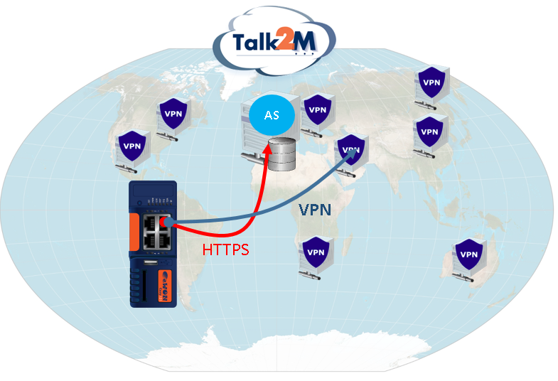
AS = Access Server, VPN = VPN Server

The different URLs used by Talk2M are explained in the KB-0209 (talk2m_used_addresses_and_ports) available on our support website.
- Firewall Recommendation -
In case of outgoing traffic restrictions, we recommend to whitelist the Talk2M domain
*.talk2m.com
to ensure that in the event of maintenance or load balancing services will remain uninterrupted.

Internet Wizard
Here is a short description of the steps performed when you launch the Internet Wizard test of an eWON Flexy/Cosy.
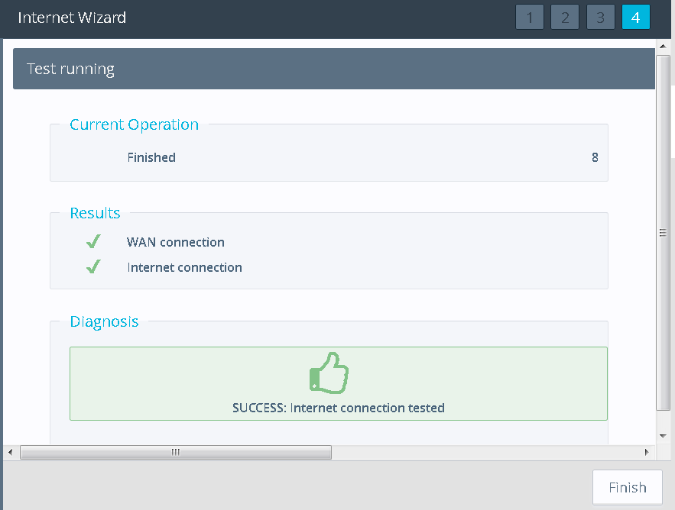

WAN Connection
- Over Ethernet with DHCP enabled : The eWON Flexy/Cosy sends a DHCP broadcast packet to the network to get its IP configuration and then checks if the configuration received is correct and does not conflict with the LAN interface IP Settings (The WAN and LAN interfaces cannot be in the same subnet).
- Over Ethernet with Static IP address : The eWON applies the static IP configuration and checks whether the gateway is part of the IP network.
- Over Wifi : The eWON negotiates the connection parameters with the hotspot and then connects to it (Wifi Status LED becomes green).
- Over Cellular connection : The eWON configures the modem and launches the 3/4G connection (internally known as “PPP connection”).

Internet Connection
During this step, the eWON performs an HTTP GET (Port 80) to the Talk2M access server URL.
See KB-0209-0-en-talk2m_used_addresses_and_ports.pdf to know the exact URL used.
If the test fails, it does not prevent you to execute the Talk2M Wizard. This test may fail while the Talk2M Wizard will be successful.

Talk2M Wizard Registration Steps

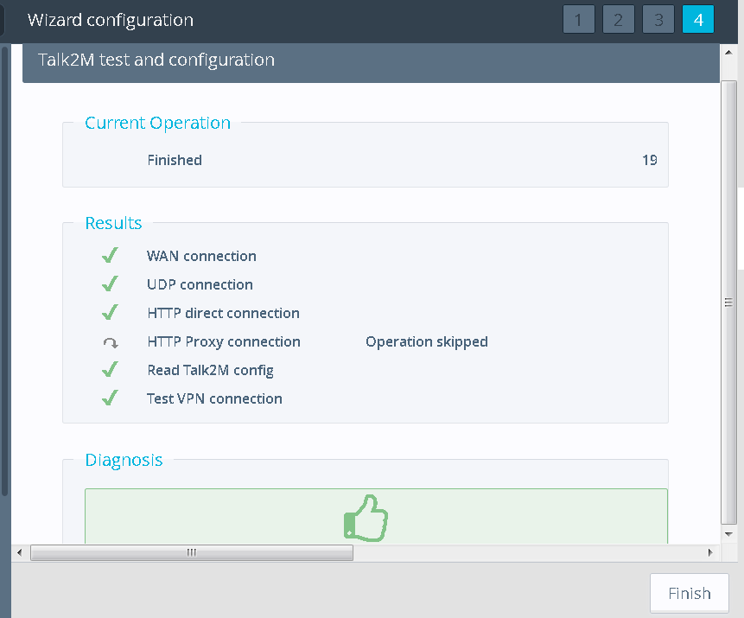

WAN Connection
- Over Ethernet with DHCP enabled : The eWON Flexy/Cosy sends a DHCP broadcast packet to the network to get its IP configuration and then checks if the configuration received is correct and does not conflict with the LAN interface IP Settings (The WAN and LAN interfaces cannot be in the same subnet).
- Over Ethernet with Static IP address : The eWON applies the static IP configuration and checks whether the gateway is part of the IP network.
- Over Wifi : The eWON negotiates the connection parameters with the hotspot and then connects to it (Wifi Status LED becomes green).
- Over Cellular connection : The eWON configures the modem and launches the 3/4G connection (internally known as “PPP connection”).

UDP Connection
The eWON Flexy/Cosy sends an UDP packet to the Talk2M Access Server on the port 1194 and this packet is echoed back to the eWON. If this UDP exchange works, the eWON will choose UDP1194 for the VPN connection. If no response is received, the eWON will use the TCP port 443 for the VPN connection.
Sometimes, the UDP Connection test may be successful but the VPN connection still doesn't work. In this case, you can try to force the VPN Connection to use TCP443 by selecting this option :
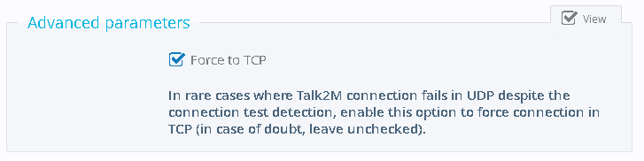

HTTP Direct Connection
The eWON performs an HTTPS GET to the Talk2M access server URL.
See KB-0209-0-en-talk2m_used_addresses_and_ports.pdf to know the exact URL used.
As the HTTPS port is TCP443, this test also checks whether the outgoing TCP port 443 is opened for the VPN connection.

HTTP Proxy Connection
In case a Proxy server has been configured during the Talk2M Wizard, the eWON Cosy/Flexy makes the same operation as the “HTTP Direct Connection” test but through the Proxy Server.
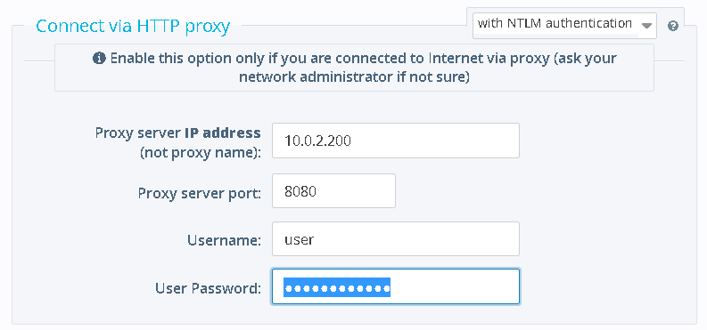

Read Talk2M Config
The eWON Flexy/Cosy connects to a specific web service on the Talk2M Access Server in order to download the VPN certificates as well as the VPN Server URL/IP Address.

Test VPN Connection
The eWON Flexy/Cosy negotiates the VPN connection with its assigned VPN server (See Chapter 4.5) in TCP or UDP according to the above tests.

Connection procedure of an already configured eWON
When an eWON Cosy/Flexy is already configured, is installed on site and powered on, it performs these two operations :
- The eWON connects to the Talk2M Access server to get its assigned VPN Server URL/IP Address through HTTPS (TCP443).
- The eWON connects then to the VPN server in TCP443/UDP1194, according to the result of the last execution of the Talk2M Wizard test.

What if the Access Server is blocked ?
The eWON will then use the latest assigned VPN server address gotten from the last successful Access Server connection.
See eWON event log :
“ovpn-Could not read Talk2M VPN server address, using last valid”.
However, a blocked access server connection makes problems when switching the eWON to another VPN server. This may happen during a VPN server maintenance or a VPN server issue

What if the configured VPN port (UDP1194 or TCP443) is blocked on site?
If you use the firmware 12.3 or higher, the eWON Cosy/Flexy will automatically try to connect to the VPN server using the other port (UDP1194 > TCP443 > UDP1194).
If you use a firmware lower than 12.3, the Talk2M Wizard must be executed on site again or the settings “VPNProto” and “VPNPortOut” must be changed manually through the advanced settings menu.

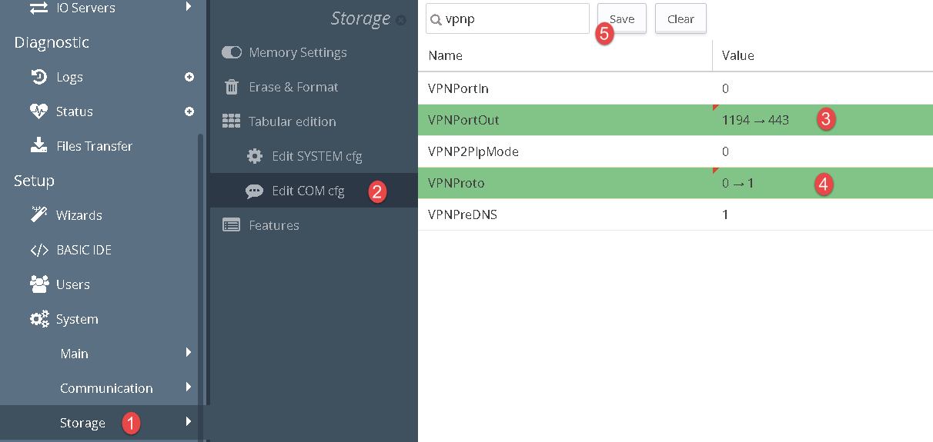

How/When the VPN server is chosen for your eWON and how to change it ?
Talk2M assigns a VPN server to your Talk2M account when you create this account in eCatcher :
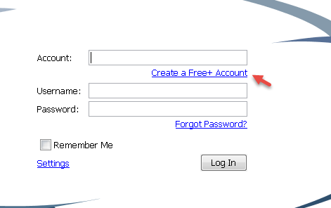
To choose the VPN server, Talk2M geo-locates the Internet connection's public IP address of the PC used to do this operation and the nearest VPN Server is then assigned to all the eWONs contained in this account.
If, for a reason, this server must be changed for a specific eWON or for the whole Talk2M account, contact your local distributor or HMS representative.

Revision

Revision History
Revision Level | Date | Description
1.0 | 1611/2018 | Creation of document
Document build number: 32
Note concerning the warranty and the rights of ownership:
The information contained in this document is subject to modification without notice. Check http://support.ewon.biz for the latest documents releases.
The vendor and the authors of this manual are not liable for the errors it may contain, nor for their eventual consequences.
No liability or warranty, explicit or implicit, is made concerning the quality, the accuracy and the correctness of the information contained in this document. In no case the manufacturer's responsibility could be called for direct, indirect, accidental or other damage occurring from any defect of the product of errors coming from this document.
The product names are mentioned in this manual for information purposes only. The trade marks and the product names or marks contained in this document are the property of their respective owners.
This document contains materials protected by the International Copyright Laws. All reproduction rights are reserved. No part of this handbook can be reproduced, transmitted or copied in any way without written consent from the manufacturer and/or the authors of this handbook.
HMS Industrial Networks SA

